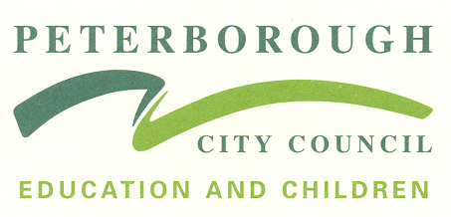 Two-Year-Old Progress Check 

Child’s Name: ……………………………………………………... Age in Months (at time of completion) ……………..…...

Date completed …………………………………………………...

DOB |  |  | Languages Spoken at Home
Setting/ childminder Name |  |  | Key Person  (Name and signature)
Date Started |  |  | Sessions booked per week: | Average weekly attendance over the last 4 weeks:
Parent Comments:  Signed: |  |  | Review of previous next steps/interventions:
Other Settings Attended: |  |  | Professionals currently working with the Family:

My Summary: Prime Areas of Development

COMMUNICATION & LANGUAGE – (Listening, Attention & Understanding and Speaking skills) | PERSONAL SOCIAL & EMOTIONAL - (Self-Regulation, Managing Self and Building Relationships) |  | PHYSICAL  – (Gross Motor and Fine Motor skills)

My interests & strengths / Identified needs

Interests and strengths | Identified needs at home and in setting / Further support needed
Characteristics of Effective Learning displayed:

Next steps to support child’s learning and development:

