|  |
| --- |
| **Transition to School 2024** |

|  |  |  |  |
| --- | --- | --- | --- |
| Child’s Name: | Date of Birth: | Date summary completed: | Photo |
| Setting name, telephone and email: | Language(s) spoken at home:  For a child learning English as an additional language consider proficiency in English & tick a box below:   * New to learning English (not yet understanding or speaking English words) * Becoming familiar with English (understands some English words but not yet using them) * Becoming more confident with English (understands and uses English words) Circle one of the following descriptions – uses single words / 2-3 words sentences / 4-6 words sentences. | |
| Key Person: |
| Attendance: |
| How long attended? |
| SEND transfer sheet included: yes/no |

|  |
| --- |
| **More About Me …** |
| **Parent/Carer Comments:**  Please tell us what you and your child enjoy doing together at home:  How are you and your child are feeling about moving on to school, do share any concerns? |

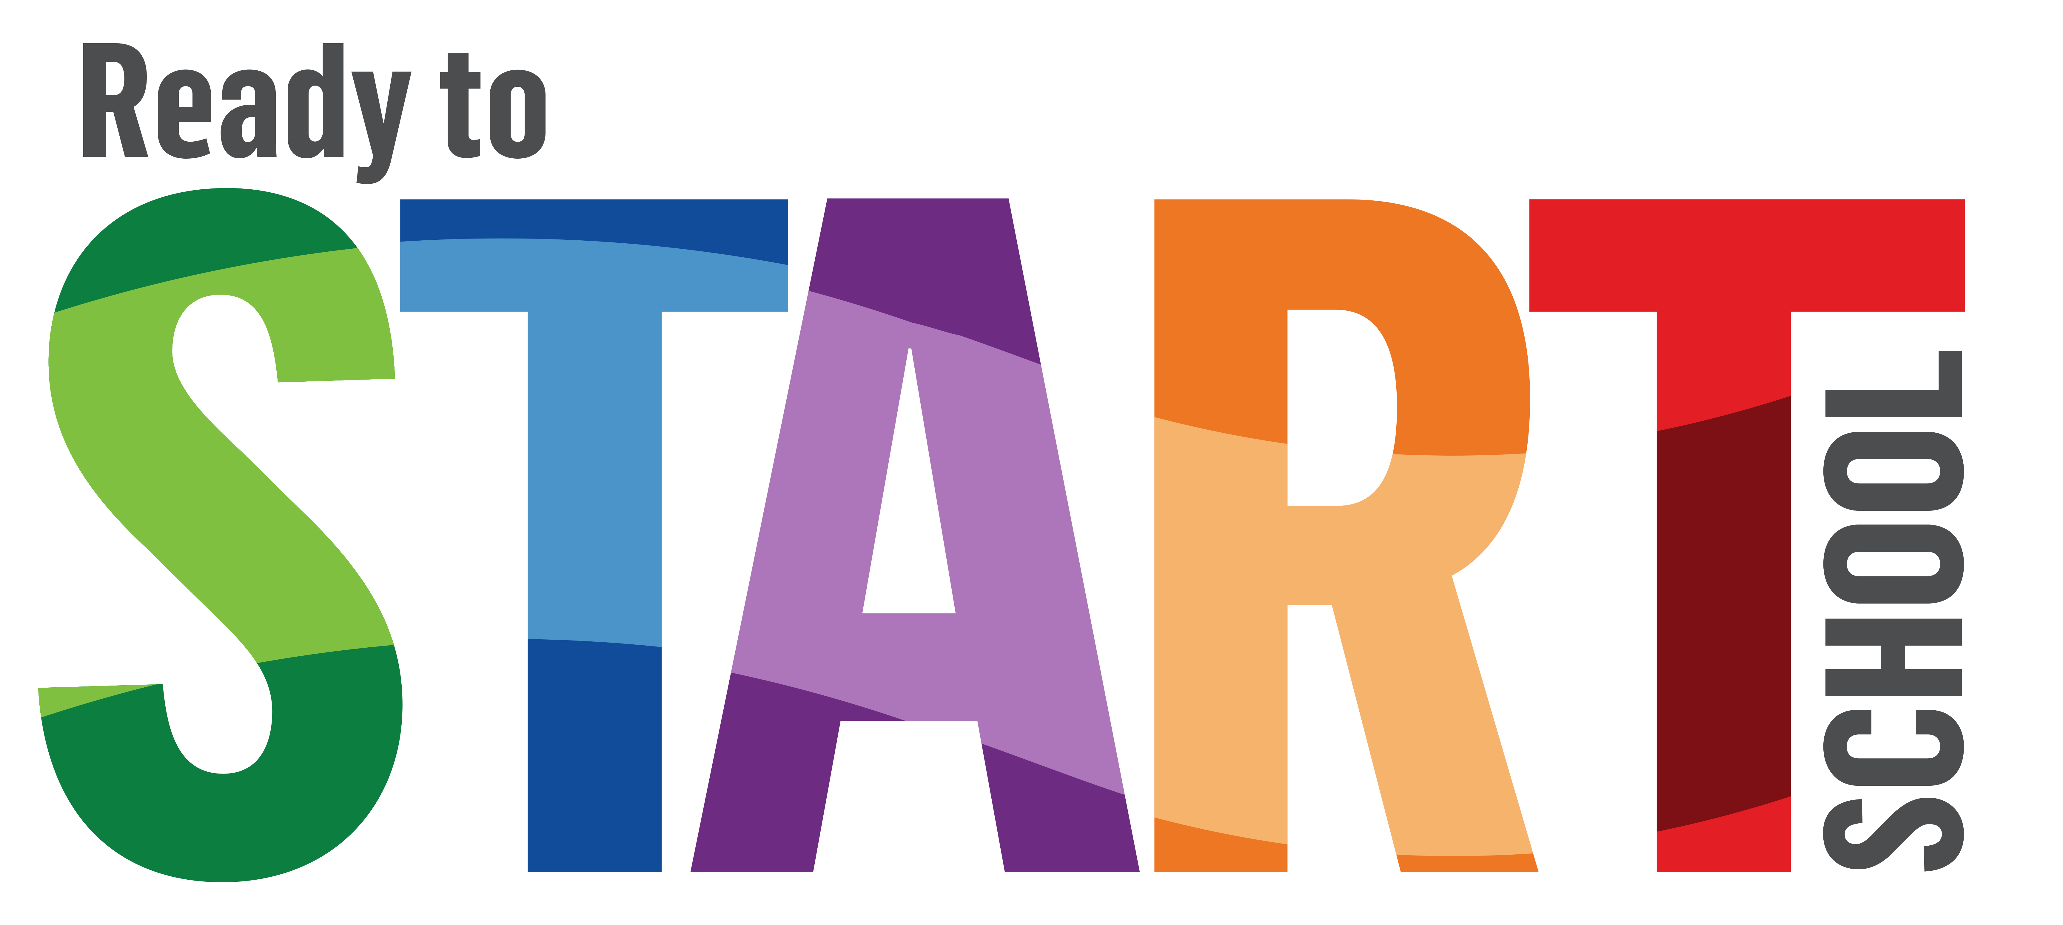

**Describe aspects I can manage independently and any support I need with each**

|  |  |
| --- | --- |
| Shoes, socks and putting on clothes | Ready to try different foods |
| Talk, listen, share and follow instructions | Ready to use different tools |
| Ask for help | Toilet on their own |

|  |
| --- |
| **Summary of Prime Areas of Learning**  I’m doing well with  I need support with |

|  |  |  |  |
| --- | --- | --- | --- |
| **Summary of Specific Areas of Learning**  I’m doing well with  I need support with | | | |

|  |
| --- |
| **Any other information you wish the Reception teacher to be aware of:** |