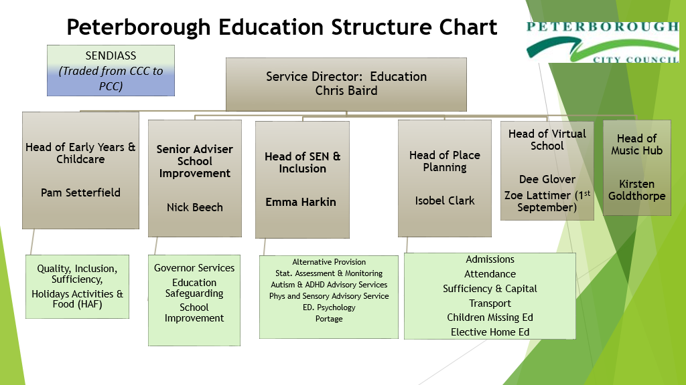

Contact | Email
School Improvement Admin Team | schooleffectivenessadmin@peterborough.gov.uk
Educational Psychology Service | EPS@peterborough.gov.uk
Virtual Schools | virtualschool@peterborough.gov.uk
SEN / Inclusion | sen@inclusion@peterborough.gov.uk
Statutory Assessment & Monitoring Service | senteam@peterborough.gov.uk
Early Years / Childcare | earlyyearsandchildcare@peterborough.gov.uk
Training Bookings | childcaretraining@peterborough.gov.uk
Nursery Funding Enquiries | nurseryeducationfunding@peterbrough.gov.uk
2-year-old Funding Application Queries | freefortwos@peterborough.gov.uk
Families Information Service | fis@peterborough.gov.uk / 01733 86444
Music Hub | Musichub@peterborough.gov.uk
School and College Transport | educationtransport@peterborough.gov.uk
Childrens Social care Transport | socialcaretransport@peterborough.gov.uk
School Admissions | admissions@peterborough.gov.uk
Appeals | appealsservice@peterborough.gov.uk
Attendance | asadmin@peterborough.gov.uk
CME | cme@peterborough.gov.uk
EHE | homeeducation@peterborough.gov.uk
Fair Access | PCCfairaccess@peterborough.gov.uk
Education Feedback | education.feedback@peterborough.gov.uk
Service Director of Education – Chris Baird  Executive Assistant – Chloe Harris | Chris.baird@peterborough.gov.uk  Chloe.Harris@peterborough.gov.uk
Executive Director Children and Young People’s Service  Executive Assistant – Clair Curtis | John.gregg@peterborough.gov.uk  clair.curtis@peterborough.gov.uk

